Android Camera Framework Architecture

- The goal of android project is to create succesfully real-world product that improves the mobile experience for end users.

- Camera use cases

- Live Preview of camera stream
- capture a frame
- video recording of a camera stream

- Android Camera

The Android framework includes support for various cameras and camera features available on devices, allowing you to capture pictures and videos in your applications. This document discusses a quick, simple approach to image and video capture for users.

- The Android framework supports capturing images and video through the android.hardware.camera API .

- To take pictures with this class, use the following steps:

- Obtain an instance of Camera from open(int).
- Get existing (default) settings with getParameters().
- If necessary, modify the returned Camera.Parameters object and call setParameters(android.hardware.Camera.Parameters).
- Call setDisplayOrientation(int) to ensure correct orientation of preview.
- Call startPreview() to start updating the preview surface. Preview must be started before you can take a picture.
- Call stopPreview() to stop updating the preview surface.
- Call release() to release the camera for use by other applications.

Camera Architecture :

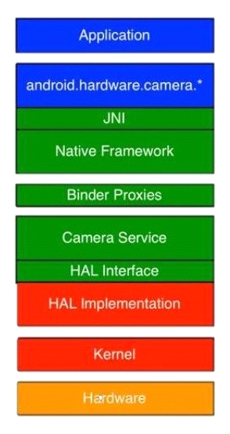
framework/base/core/java/android/harware/camera.java

API
frameworks/base/core/jni/android_hardware_Camera.cpp.

frameworks/av/camera/Camera.cpp

frameworks/av/camera
Icamera
Icameraservice
Icameraclient

frameworks/av/services/camera/libcameraservice/CameraService.cpp

hardware/libhardware/include/hardware/camera.h

hardware/<vendor>/camera/Qcamera2/HAL/Qcamera2HWI.cpp

kernel/drivers/media/v4l2

Application Framework :

- At the application framework level is the app's code, which utilizes the android.hardware.Camera API to interact with the camera hardware. Internally, this code calls a corresponding JNI glue class to access the native code that interacts with the camera.
- Java classes Exposed to the application for interfacing with the hardware.
Framework/base/core/java/android/harware/camera.java

EX :

public Parameters getParameters() {
Parameters p = new Parameters();
String s = native_getParameters();
p.unflatten(s);
return p;
}

JNI :

- It is the glue code between java classes and native classes
- The JNI code associated with android.hardware.Camera is located in
frameworks/base/core/jni/android_hardware_Camera.cpp.

EX :

static jstring android_hardware_Camera_getParameters(JNIEnv *env, jobject thiz)
{
ALOGV("getParameters");
sp<Camera> camera = get_native_camera(env, thiz, NULL);
if (camera == 0) return 0;

Native framework :

- The native framework defined in frameworks/av/camera/Camera.cpp . This class calls the IPC binder proxies to obtain access to the camera service.

EX :

String8 Camera::getParameters() const
{
ALOGV("getParameters");
String8 params;
sp <::android::hardware::ICamera> c = mCamera;
if (c != 0) params = mCamera->getParameters();
return params;
}

Binder IPC proxies :

- The IPC binder proxies facilitate communication over process boundaries. There are three camera binder classes that are located in frameworks/av/camera directory that calls into camera service.
- ICameraService is the interface to the camera service,
- ICamera is the interface to a specific opened camera device.
- and ICameraClient is the device's interface back to the application framework.

EX :

String8 getParameters() const
{
ALOGV("getParameters");
Parcel data, reply;
data.writeInterfaceToken(ICamera::getInterfaceDescriptor());
remote()->transact(GET_PARAMETERS, data, &reply);
return reply.readString8();
}

Camera service :

- The camera service, located in frameworks/av/services/camera/libcameraservice/CameraService.cpp, is the actual code that interacts with the HAL.
- It manages permissions and lifecycle of the camera devices.

HAL interface :

- hardware intercace loactaed in hardware/libhardware/include/hardware see camera.h and camera_common.h files
- The Camera Hardware Abstraction Layer (HAL) is a library that is specific to the camera hardware platform
- Written by hardware vendors (like Qualcomm, TI)

HAL implementation :

- hardware specific implementations depends on host processor ,isp and sensor located in hardware/<vendor>/camera/Qcamera2/HAL/Qcamera2HWI.cpp

Kernel drivers :

- In general, the low-level implementation of the Camera APIs is V4L2,the camrea driver itself in kernel/drivers/media/v4l2

- Implementing the HAL

The HAL sits between the camera driver and the higher-level Android framework. The HAL interface is defined in the hardware/libhardware/include/hardware/camera.h and hardware/libhardware/include/hardware/camera_common.h header files.

camera_common.h defines camera_module, a standard structure to obtain general information about the camera, such as the camera ID and properties common to all cameras (that is, whether it is a front- or back-facing camera).

Configuring the shared library
- Create a device/<company_name>/<device_name>/camera directory to contain your library's source files.

- Create an Android.mk file to build the shared library. Ensure that the makefile contains the following lines:
LOCAL_MODULE := camera.<device_name>
LOCAL_MODULE_RELATIVE_PATH := hw

3 . Specify your device has camera features by copying the necessary feature XML files in the frameworks/native/data/etc directory with your device's makefile. For example, to specify your device has a camera flash and can autofocus, add the following lines in your device's <device>/<company_name>/<device_name>/device.mk makefile:
For an example of a device makefile, see device/samsung/tuna/device.mk.
4 . Declare your camera’s media codec, format, and resolution capabilities in device/<company_name>/<device_name>/media_profiles.xml and device/<company_name>/<device_name>/media_codecs.xml XML files.
5. Add the following lines in your device's device/<company_name>/<device_name>/device.mk makefile to copy the media_profiles.xml and media_codecs.xml files to the appropriate location:

# media config xml file
PRODUCT_COPY_FILES += \
<device>/<company>/<device>/media_profiles.xml:system/etc/media_profiles.xml

6 . To include the Camera app in your device's system image, specify it in the PRODUCT_PACKAGES variable in your device's device/<company>/<device>/device.mk makefile:
PRODUCT_PACKAGES := \
Gallery2 \
...

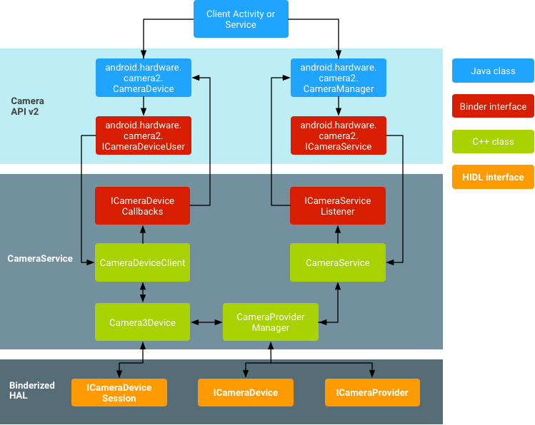

Fig : Android Camera Architecture

